EMPLOYEE RAISE ISSUE – RECORD PRODUCER & SERVICE PORTAL INTEGRATION
PHASE 3: Creating UI Policies and Field Dependency

1. Introduction
This phase controls the dynamic behavior of the Employee Raise Issue form. UI Policies enforce field behavior, while a dictionary dependency controls Subcategory choices according to Category.

2. Objective
To configure mandatory and read-only behavior and establish the Category–Subcategory dependency.

3. UI Policy 1 – Short Description Mandatory
1. Navigate to All and search for UI Policies.
2. Click New.
3. Set Table to Employee Raise Issue.
4. Set the condition: State is New.
5. Save the UI Policy.
6. Under Related Links → UI Policy Actions, click New.
7. Select Short description as the Field.
8. Set Mandatory to True.
9. Leave Visible and Read only unchanged.
10. Submit and update.
11. Open the form, set State to New, and verify that Short description becomes mandatory.
UI Policy condition: State is New
UI Policy Action: Short description mandatory
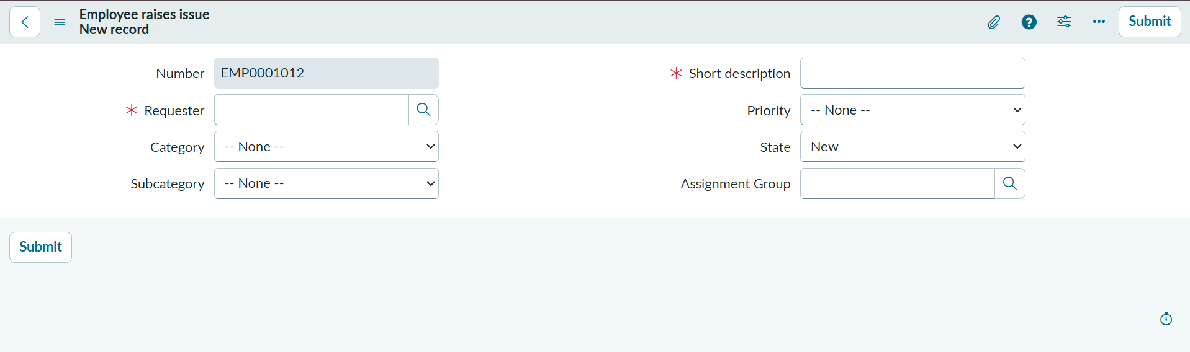

4. UI Policy 2 – Number Read Only
1. Create another UI Policy for Employee Raise Issue.
2. Leave the filter condition empty.
3. Save the policy.
4. Under UI Policy Actions, click New.
5. Select Number as the Field.
6. Set Read only to True.
7. Leave Mandatory and Visible unchanged.
8. Submit and update.
9. Open the form and verify that Number cannot be edited.
UI Policy Action: Number read-only
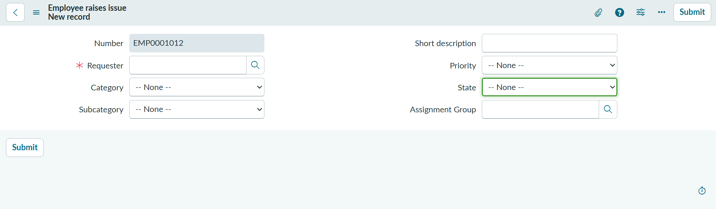
A Dictionary Override can also be used when a dictionary-level setting needs to be overridden for a particular table.

5. Category–Subcategory Dependency
1. Open the Employee Raise Issue table form.
2. Right-click Subcategory and select Configure Dictionary.
3. Open Advanced view.
4. Set the dependent field to Category.
5. Open the Choices section under Related Links.
6. Configure the dependency using the backend values of the Category choices.
7. Save and test the form.
Category | Subcategory
Network | VPN
Hardware | Laptop
Software | Server
Access | Forgot password
Dictionary configuration showing Category as the dependent field
Form showing filtered Subcategory choices
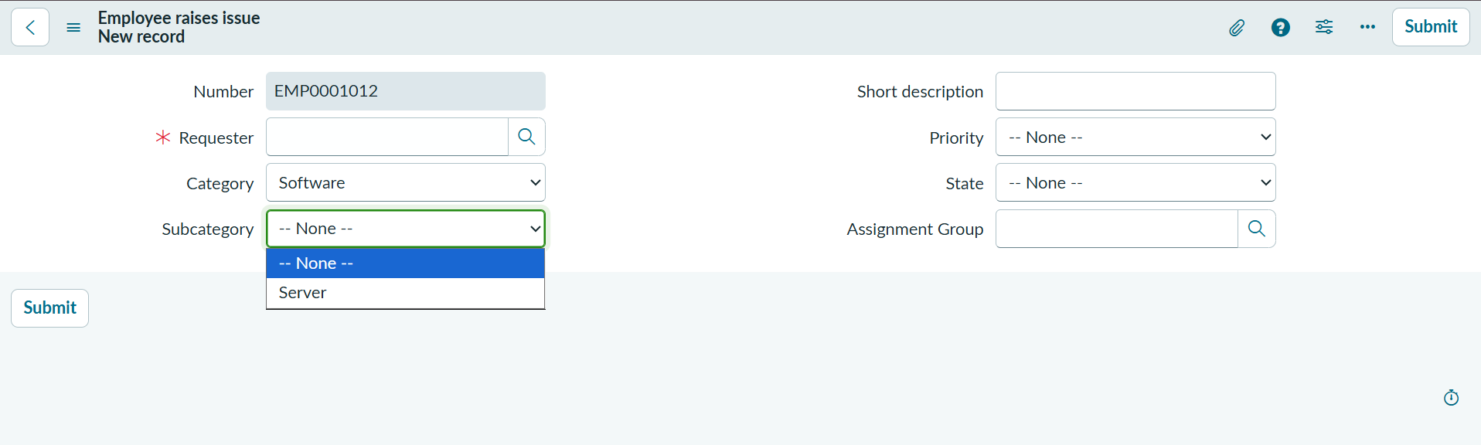

6. Result
The form now enforces the required field behavior, protects the Number field from editing, and displays relevant Subcategory choices based on Category.

